In Amazon Web Services (AWS), a VPC and a subnet are core networking components that define how your cloud resources communicate.

🌐 What is a VPC?
VPC (Virtual Private Cloud) is a logically isolated virtual network inside AWS where you launch your resources (EC2 instances, databases, etc.).
Think of a VPC as your own private data center network in the cloud.
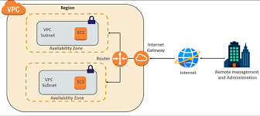
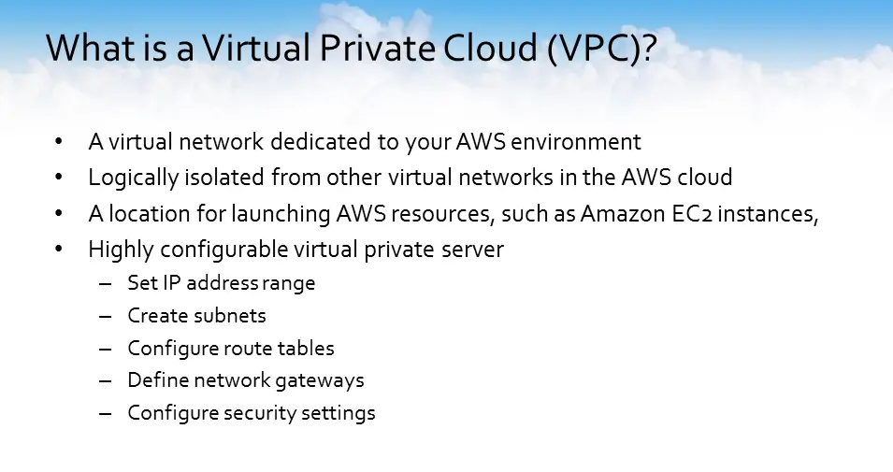

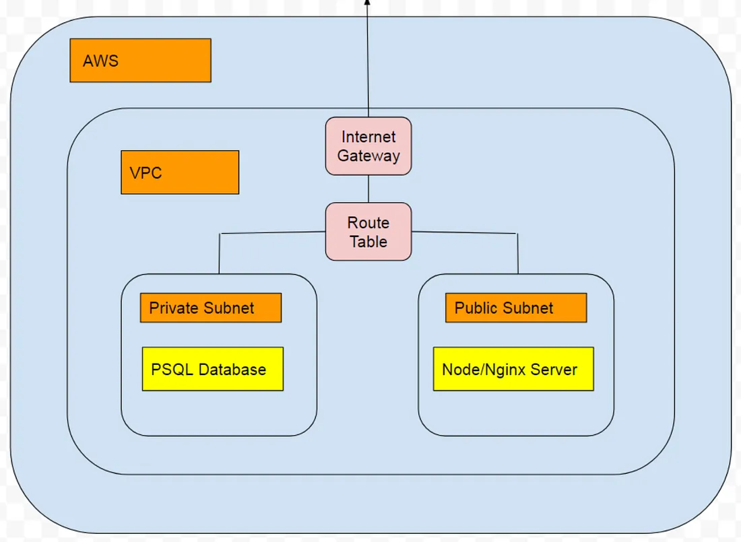
Key characteristics:
- You choose the IP address range (CIDR block), e.g., 10.0.0.0/16
- Fully isolated from other AWS customers
- You control:
  - Route tables
  - Internet access
  - Security rules
  - Subnets
  - NAT gateways, etc.

Example:
If you create a VPC with:
10.0.0.0/16
You now own all IPs from:
10.0.0.0 → 10.0.255.255


🏢 What is a Subnet?
A subnet is a smaller network inside a VPC.
You divide your VPC into multiple subnets to organize resources.
Think of:
- VPC = Entire building
- Subnets = Individual rooms

Example:
Inside VPC 10.0.0.0/16, you might create:
- 10.0.1.0/24 → Public Subnet
- 10.0.2.0/24 → Private Subnet
- 10.0.3.0/24 → Database Subnet
Each subnet:
- Lives inside one Availability Zone
- Has its own routing behavior
- Can be public or private

🔓 Public vs Private Subnet

Public Subnet
- Has a route to an Internet Gateway
- Resources can have public IPs
- Used for:
  - Web servers
  - Load balancers

Private Subnet
- No direct internet route
- Used for:
  - Databases
  - Backend services
- Can access internet via NAT Gateway

🔁 How They Work Together
- You create a VPC
- You create subnets inside it
- You launch resources inside subnets
- Route tables control traffic
- Security groups control access

🔍 Simple Real-World Analogy
AWS Concept | Real World
VPC | Apartment building
Subnet | Apartment unit
Internet Gateway | Main entrance
Route Table | Building map
Security Group | Door lock

🌐 What is a Subnet (in AWS)?
In Amazon Web Services, a subnet (subnetwork) is a smaller network inside a VPC.
A VPC gives you a big IP range (like 10.0.0.0/16), and a subnet divides that range into smaller pieces (like 10.0.1.0/24).
👉 You launch your resources (EC2, RDS, etc.) inside a subnet, not directly in a VPC.

🏗 Simple Example
If your VPC is:
10.0.0.0/16
You can create subnets like:
- 10.0.1.0/24
- 10.0.2.0/24
- 10.0.3.0/24
Each subnet:
- Belongs to one Availability Zone
- Has its own routing behavior
- Contains a limited number of IP addresses

🔢 How Many Types of Subnets?
In AWS, there are mainly 2 types:

1️⃣ Public Subnet
A subnet is public if:
- Its route table has a route to an Internet Gateway
- Instances can get public IPs

Used for:
- Web servers
- Load balancers
- Bastion hosts
👉 These resources can communicate directly with the internet.

2️⃣ Private Subnet
A subnet is private if:
- It does NOT have a direct route to the Internet Gateway
- Instances do not have public IPs

Used for:
- Databases
- Backend services
- Internal applications
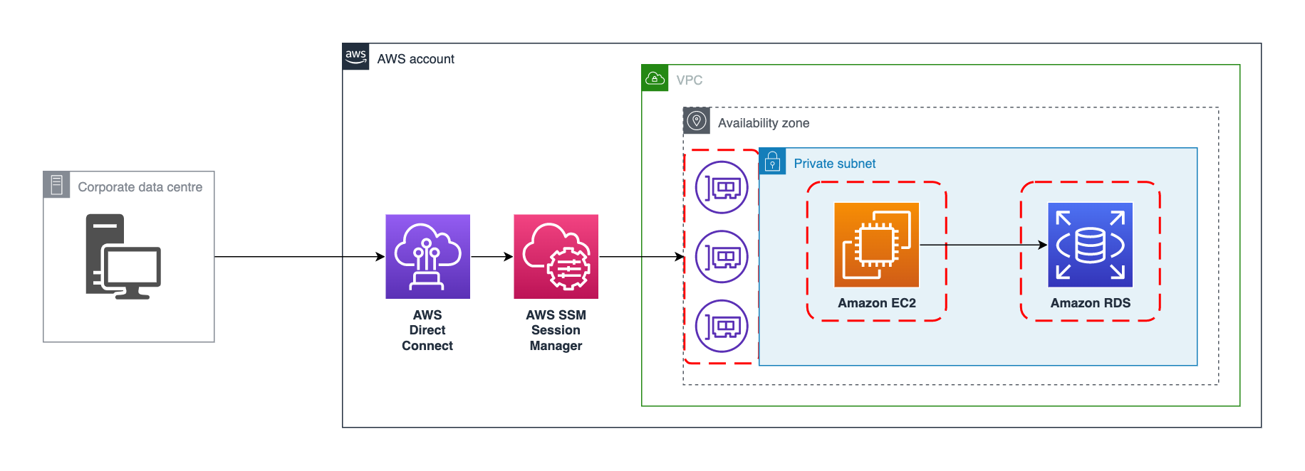
👉 These resources are hidden from the internet.

Important Note
AWS does not label a subnet as "public" or "private."
It becomes public or private based on its route table configuration.

📌 Quick Comparison
Feature | Public Subnet | Private Subnet
Internet access | Direct | No direct access
Public IP allowed | Yes | No
Typical usage | Web servers | Databases

